**September 15th to September 19th**

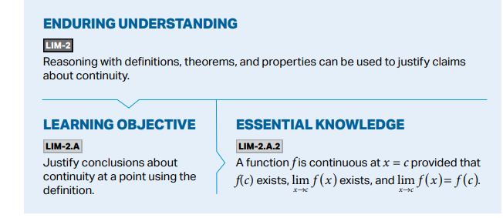Standards:

Learning Targets:

I am learning how to classify a discontinuity as a removable, jump, or infinite discontinuity.

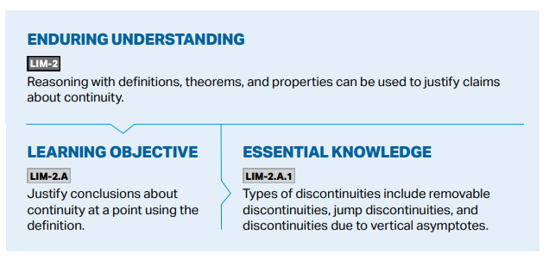 I am learning how to justify continuity and discontinuity using the limit definition of continuity.

I am learning how to identify intervals on which a function is continuous.

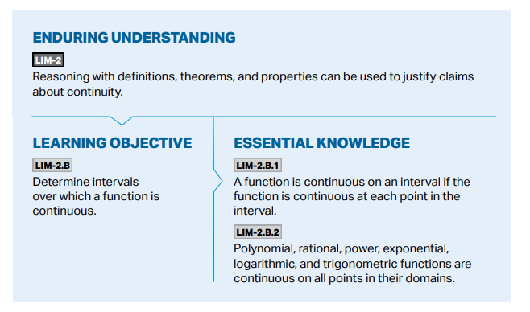I am learning how to identify when a discontinuity is removable.

I am learning about discontinuities by defining or redefining the function value at a point to match the limit value at that point.

I am learning how to solve for parameters that make a function continuous.

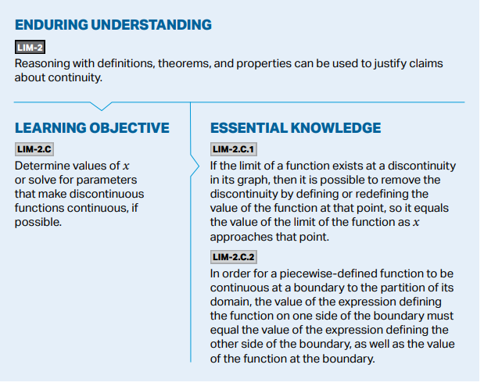Success Criteria:

I can classify a discontinuity as a removable, jump, or infinite discontinuity.

I can justify continuity and discontinuity using the limit definition of continuity.

I can identify intervals on which a function is continuous.

I can identify when a discontinuity is removable.

I can remove discontinuities by defining or redefining the function value at a point to match the limit value at that point.

I can Solve for parameters that make a function continuous.

**Week at a Glance AP Calculus**

Monday: 1.8 Removing Discontinuity

Tuesday: 1.9 The Intermediate Value Theorem

Wednesday: AP classroom/ Khan Academy Practice Squeeze Theorem, Continuity and Discontinuity, Removing Discontinuity

Thursday: AP classroom Review for Unit 1 Test

Friday: AP classroom Review for Unit 1 Test